COEN 146

LAB 1

**Network Link Evaluation**

***Written by Karan Daryanani***

**Introduction:** This goal of the first lab is to familiarize us with testing network links. To do so, we measured the total CPU time of transferring a file of N bits, and plotted it against different values of N. The change in the volume of data allowed us to see that network links are not linear, but they are close.

**Data:**

|  |  |
| --- | --- |
| Total Time (s) Bytes(MB) | |
|  |  |
| 0.485 | 100 |
| 0.943 | 200 |
| 1.416 | 300 |
| 1.767 | 400 |
| 2.54 | 500 |
| 2.813 | 600 |
| 3.261 | 700 |
| 3.729 | 800 |
| 3.985 | 900 |
| 4.286 | 1000 |

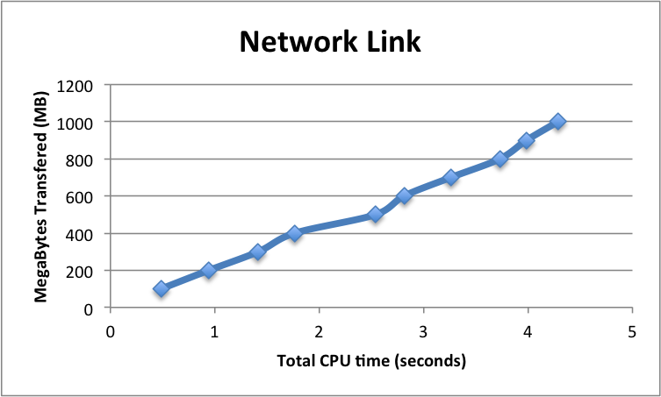

**Testing:**

To execute the tests, I used the following procedure. I incremented the number of bytes by 100 MB each test in increments of 100 all the way up to 1000 MB. I also changed the target file name each time so a new file would be created and no data would be overwritten. The command line code for a few examples can be found below.

[kdaryana@linux60814 Documents]$ time cat test |head -c 900000000 | ssh kdaryana@linux.scudc.scu.edu "(cd /DCNFS/users/student/kdaryana/Documents &&cat -> lab900.txt)"

real 0m27.687s

user 0m2.818s

sys 0m1.736s

[kdaryana@linux60814 Documents]$ time cat test |head -c 900000000 | ssh kdaryana@linux.scudc.scu.edu "(cd /DCNFS/users/student/kdaryana/Documents &&cat -> lab9000.txt)"

real 0m29.257s

user 0m2.531s

sys 0m1.454s

[kdaryana@linux60814 Documents]$ time cat test |head -c 1000000000 | ssh kdaryana@linux.scudc.scu.edu "(cd /DCNFS/users/student/kdaryana/Documents &&cat -> lab75700.txt)"

real 0m39.977s

user 0m2.689s

sys 0m1.597s

**Results:**

To analyze the data in terms of time, I researched the time function and how it works. The goal was to analyze the performance and speed. Due to this, the time result that I cared about was user and system time. When combined, they make the total CPU time. The data showed no definite patterns, but it gave me grounds for stating that transferring 100MB took approximately .2 to .6 seconds. This is quite a fast network link.

**Conclusion:**

This was a great first experience with analyzing network links. The data did not provide insight into how consistent the speeds are, but it gave me a general idea, and if I needed to analyze consistency I can do so by using the same method and collecting more data points.